Thesis Nocedal Screenshots

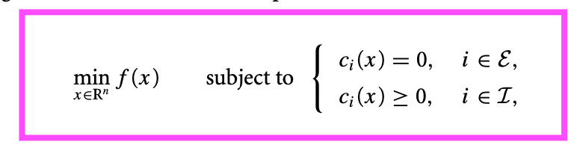

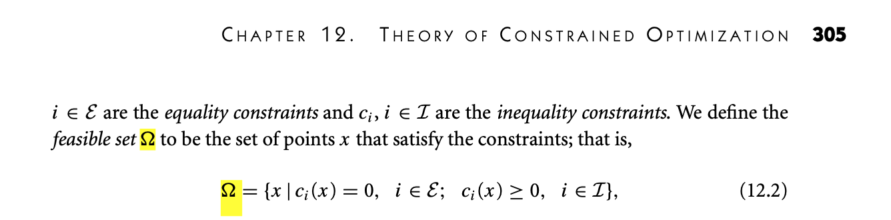
We have seen already that global solutions are difficult to find even when there are no constraints. The situation may be improved when we add constraints, since the feasible set might exclude many of the local minima and it may be comparatively easy to pick the global minimum from those that remain. However, constraints can also make things more difficult.
Book page 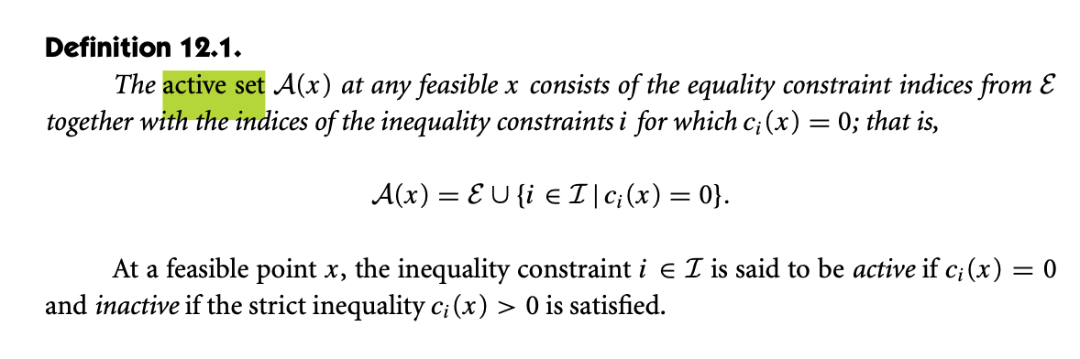308 Active set

Book page 320 (340 PDF) LICQ
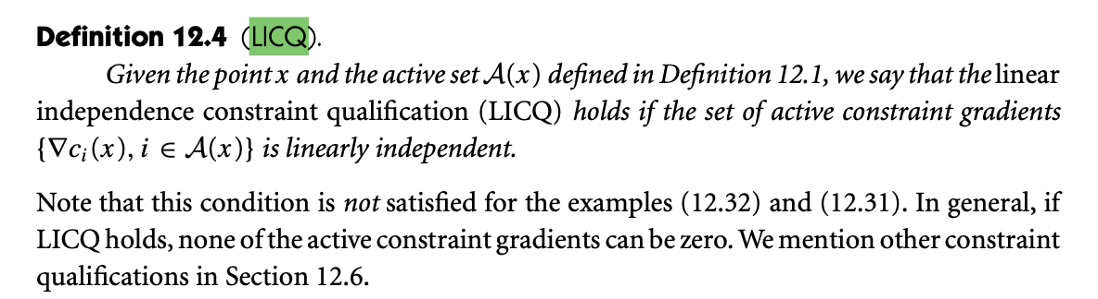
Chapter 16 Quadratic programming

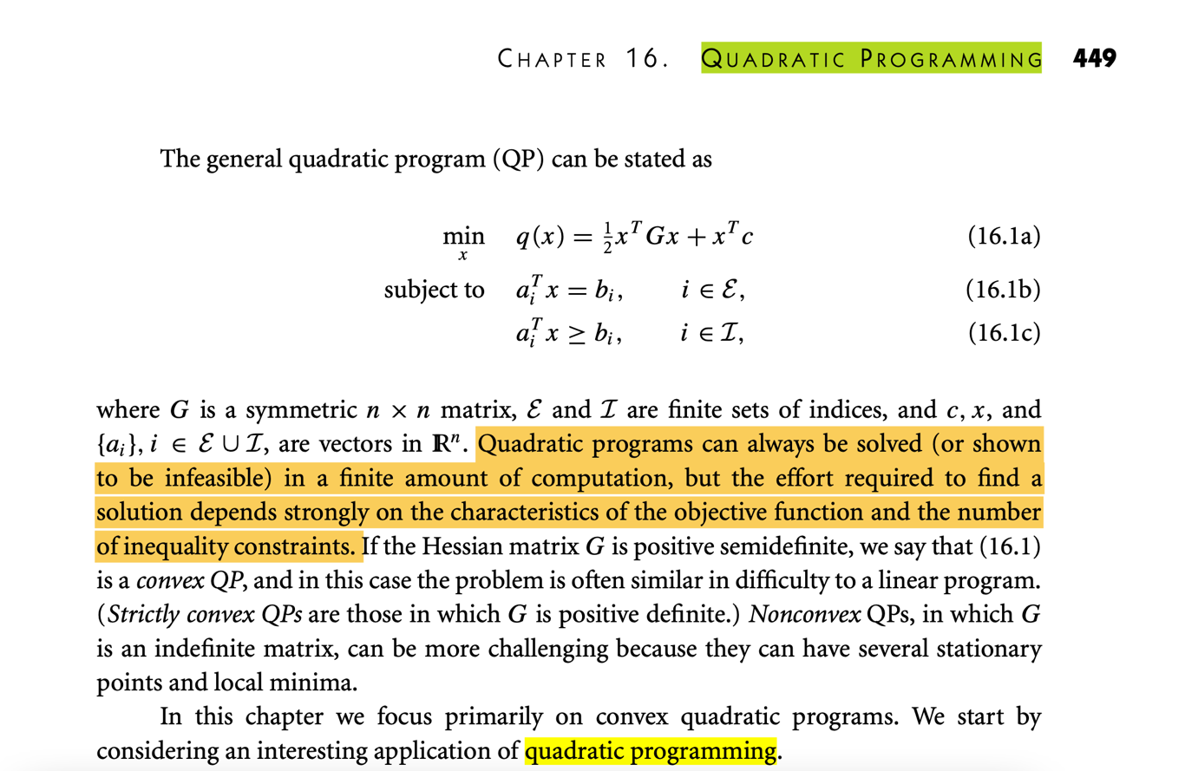
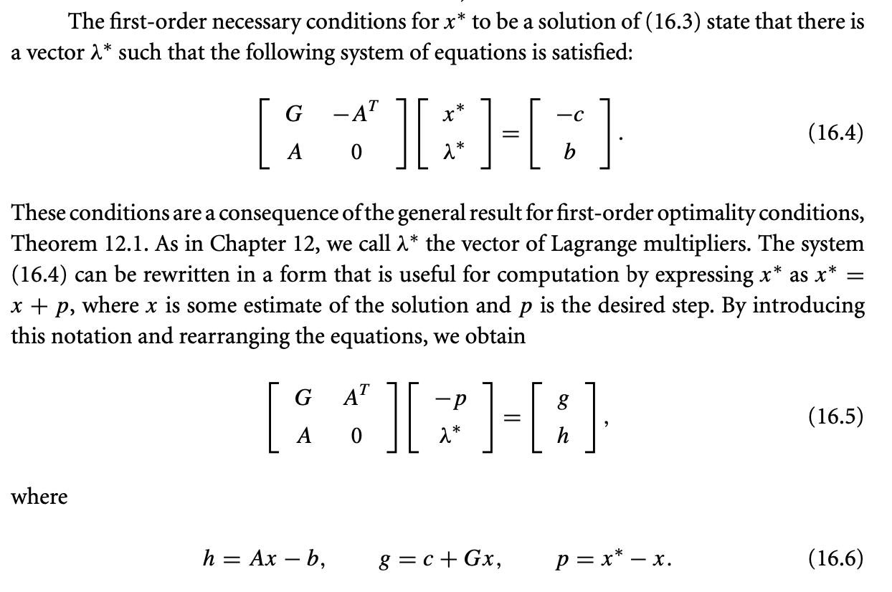

Convexity:
THE IMPORTANT THING:
If the objective function in the optimization problem (1.1) and the feasible region are both convex, then any local solution of the problem is in fact a global solution.


PROOF:
https://web.stanford.edu/~boyd/cvxbook/bv_cvxbook.pdf page 136 of PDF

“Thus, in a convex optimization problem, we minimize a convex objective
function over a convex set.”
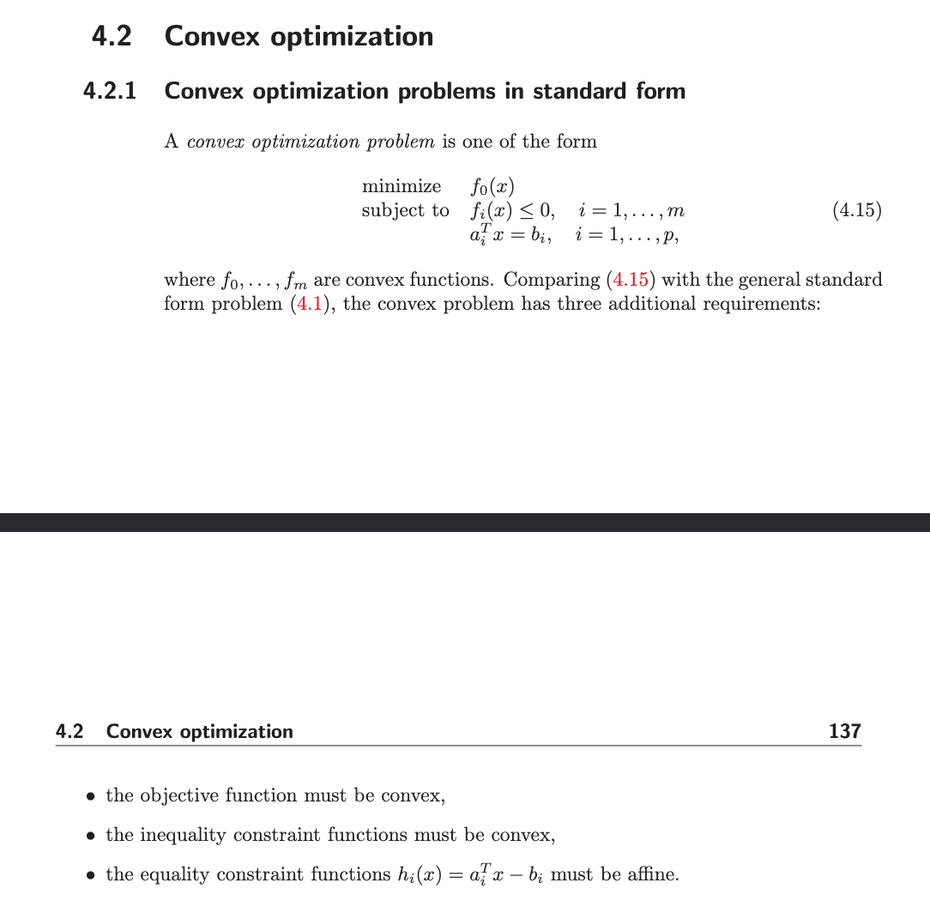

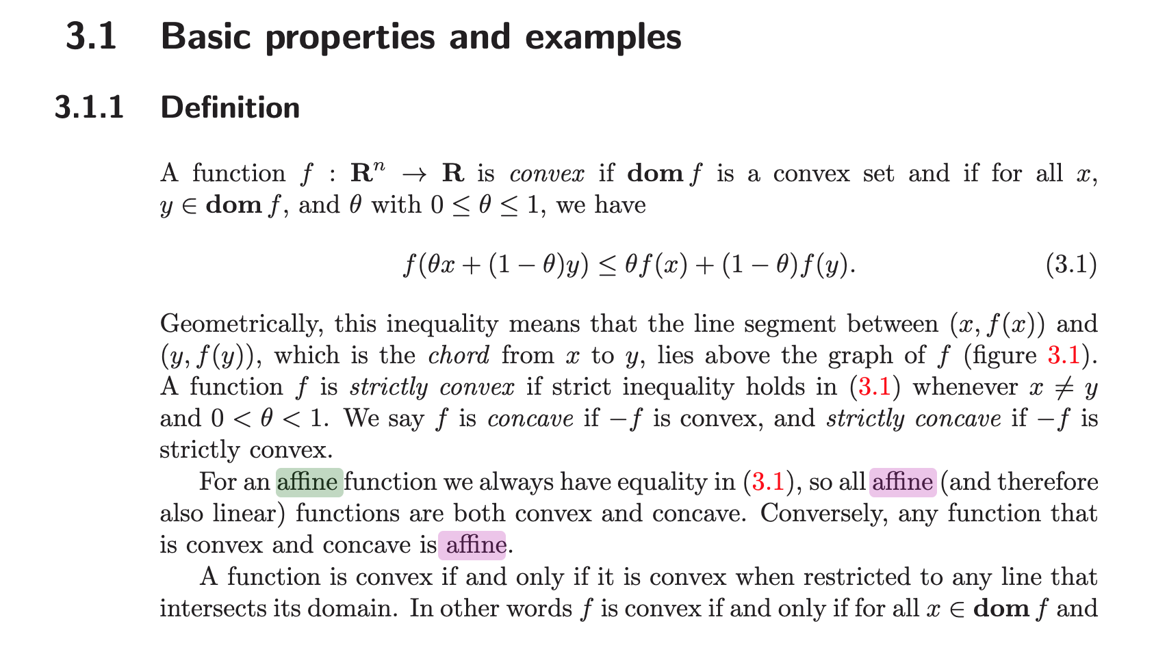
4.2.2. Local and global optima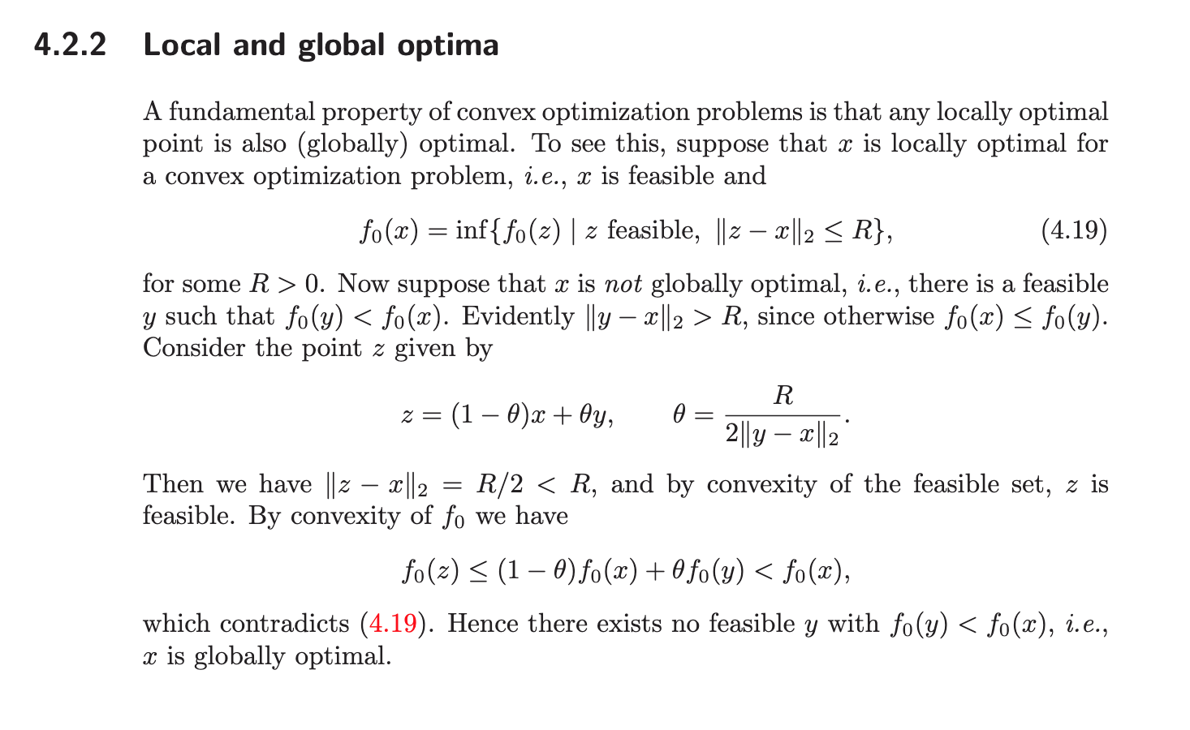

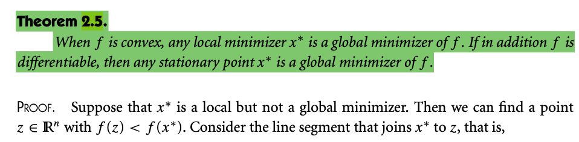
Local optima minimizer PAGE 12 MINIMISER




Page 143:

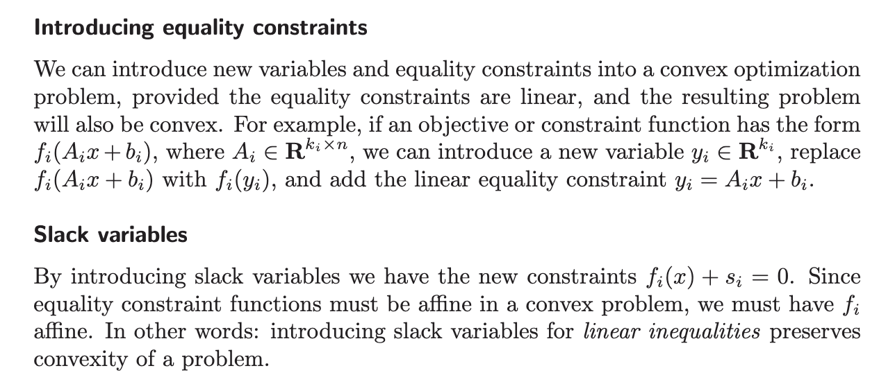

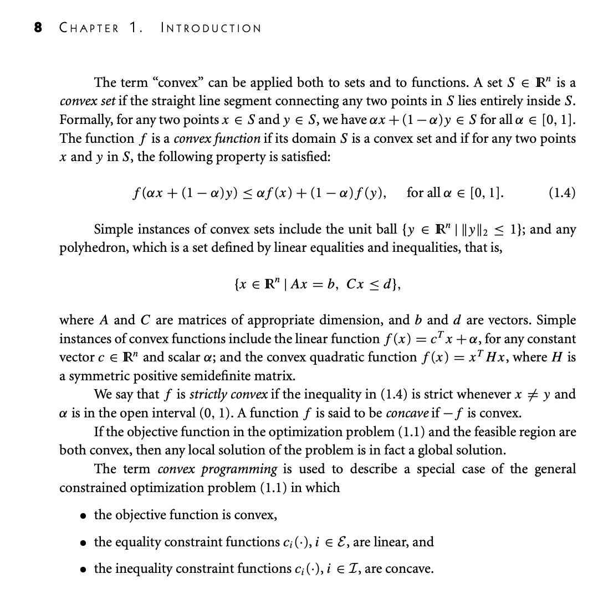

Chqpter 12: KKT and Lagrange

THESIS RESULTS CHAPTER

KKT and necessary vs sufficient conditions
Page 14
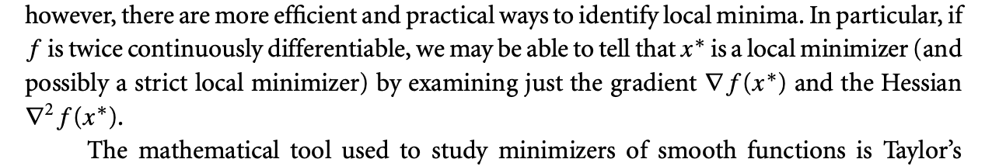

Page 305

